PIZZA SALES SQL QUERIES

1.Total Revenue

select sum(total_price) as total_revenue from pizza_sales

**Output**

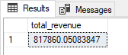

2.Average Order Value

SELECT SUM(total_price) / COUNT(DISTINCT order_id) AS Avg_order_value FROM pizza_sales

**Output**

3.Total Pizza sold

SELECT SUM(quantity)AS Total_Pizza_Sold FROM pizza_sales

**Output**

4.Total Orders

SELECT COUNT(DISTINCT order_id) AS Total_orders FROM pizza_sales

**Output**

5.Average Pizza Per Orders:

SELECT CAST(CAST(SUM(quantity) AS DECIMAL (10,2)) /

CAST(COUNT(order_id) AS DECIMAL (10,2)) AS DECIMAL (10,2)) AS Avg_Pizzas_Per_Order FROM pizza_sales

**Output**

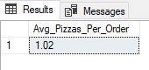

6.Daily Tread for Total Order

SELECT DATENAME(DW, order_date) AS order_day , COUNT(DISTINCT order_id) AS Total_orders

FROM pizza_sales

GROUP BY DATENAME(DW, order_date)

**Output**

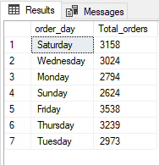

7.Month Trend for Total Orders

SELECT DATENAME(MONTH, order_date) AS Month_Name , COUNT(DISTINCT order_id) AS Total_Orders

FROM pizza_sales

GROUP BY DATENAME(MONTH, order_date)

ORDER BY Total_Orders DESC

**Output**

### 

8.Percentage of Sales by Pizza Category

SELECT pizza_category , SUM(total_price) * 100 / (SELECT SUM(total_price) FROM pizza_sales) AS PCT

FROM pizza_sales

GROUP BY pizza_category

**Output**

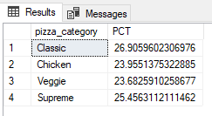

9.Total and Percentage of Sales by Pizza Category

SELECT pizza_category , SUM(total_price) AS Total_Sales, SUM(total_price) * 100 / (SELECT SUM(total_price) FROM pizza_sales) AS PCT

FROM pizza_sales

GROUP BY pizza_category

**Output**

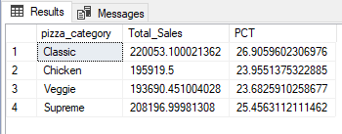

## NOTE:

If you want to appley the Month, Quarter, Week filters to the above queries you can use WHERE clause. Follow some of below examples

SELECT DATENAME(DW, order_date) AS Order_day, COUNT(DISTINCT order_id) AS Total_orders

FROM pizza_sales

WHERE MONTH (order_date) = 1

GROUP BY DATENAME(DW, order_date)

*Here MONTH(order_date)= 1 indicates AS that the output is for the month of January. MONTH(order_date) = 4 indicate output for month of April.

SELECT DATENAME(DW, order_date) AS Order_day, COUNT(DISTINCT order_id) AS Total_orders

FROM pizza_sales

WHERE DATEPART(QUARTER,order_date) = 1

GROUP BY DATENAME(DW, order_date)

*Here DATEPART(QUARTER,order_date) = 1 indicates that the output is for the Quarter 1. MONTH (order_date) = 3 indicate output for Quarter 3.

10. Sales and Percentage of Sales by Pizza size

SELECT pizza_size, CAST(SUM(total_price) AS DECIMAL(10,2)) AS Total_Sales, CAST(SUM (total_price) * 100 /

(SELECT SUM(total_price) FROM pizza_sales) AS DECIMAL (10,2)) AS PCT

FROM pizza_sales

GROUP BY pizza_size

ORDER BY PCT

**Output**

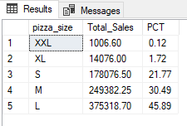

If you want to appley Quarter

SELECT pizza_size, CAST(SUM(total_price) AS DECIMAL(10,2)) AS Total_Sales, CAST(SUM (total_price) * 100 /

(SELECT SUM(total_price) FROM pizza_sales) AS DECIMAL (10,2)) AS PCT

FROM pizza_sales

WHERE DATEPART(quarter, order_date) = 1

GROUP BY pizza_size

ORDER BY PCT

**Output**

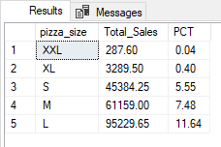

11. Top 5 Pizzas Revenue

SELECT TOP 5 pizza_name, SUM(total_price) AS Total_Revenue FROM pizza_sales

GROUP BY pizza_name

ORDER BY Total_Revenue DESC

**Output**

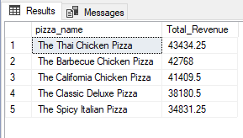

12. Bottom 5 Pizzas by Revenue

SELECT TOP 5 pizza_name, SUM(total_price) AS Total_Revenue FROM pizza_sales

GROUP BY pizza_name

ORDER BY Total_Revenue ASC

**Output**

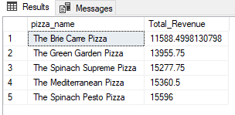

13. Top 5 Pizza Quantity

SELECT TOP 5 pizza_name, COUNT(DISTINCT order_id) AS Total_Orders

FROM pizza_sales

GROUP BY pizza_name

ORDER BY Total_Orders DESC

**Output**

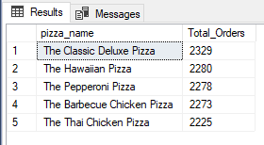

14. Bottom 5 Pizzas Quantity

SELECT TOP 5 pizza_name, COUNT(DISTINCT order_id) AS Total_Orders

FROM pizza_sales

GROUP BY pizza_name

ORDER BY Total_Orders ASC

**Output**

